NAME:G.SAI SAHITH | REG NO:192424179

EX.NO-4: LIBRARY BOOK MANAGEMENT SYSTEM
AIM:
To develop a cloud-based Library Book Reservation System using Zoho Creator for managing book reservations and to demonstrate the Software as a Service (SaaS) cloud computing model.

PROCEDURE:
- Log in to the Zoho Creator cloud platform using a valid account.
- Create a new application named SIMATS Library Book Reservation System.
- Design a form to collect student and book reservation details.
- Add fields such as Student Name, Register Number, Department, Book Title, Author, Reservation Date, Return Date, Available Copies, and Status.
- Configure drop-down lists for Department, Book Title, and Reservation Status.
- Create a report to display all reservation records.
- Add a workflow to validate the availability of books before accepting a reservation.
- Configure the workflow to automatically set the reservation status after successful submission.
- Test the application by entering sample reservation details and verify that records are stored correctly.
- Publish the application and access it through a web browser to demonstrate the SaaS model.

CODE:
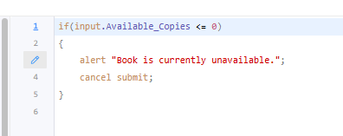

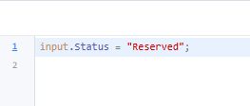

OUTPUT:
LIBRARY BOOK MANAGEMENT SYSTEM:
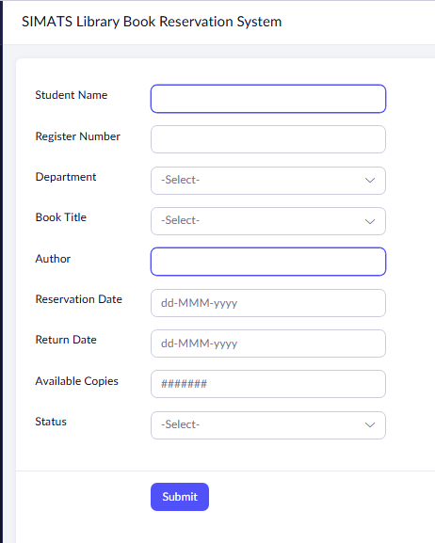

REPORT:

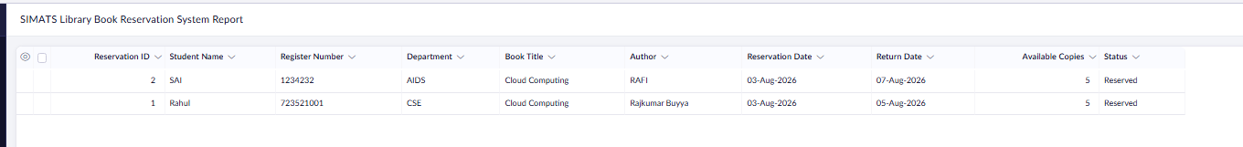

RESULT:
A cloud-based Library Book Reservation System was successfully developed using Zoho Creator. The application allows users to reserve books online and demonstrates the Software as a Service (SaaS) model by enabling access through a web browser with cloud-based data storage..

